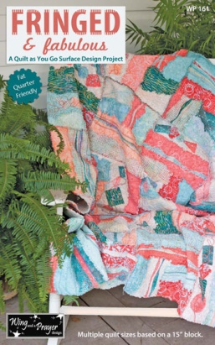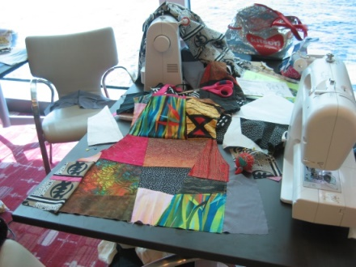Fringed & Fabulous designed and taught by Toni Steere co-founder of “Wing and a Prayer Designs” - this is one of Toni’s original designs using fat quarters to make this fun batik goes ragtime quilt. Give this fringe and fabulous a touch of embellishment and free motion quilting.
Choose Class I: Sunday from 9:00am – Noon OR Monday 2:00pm- 5:30pm
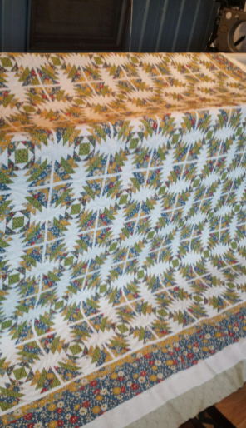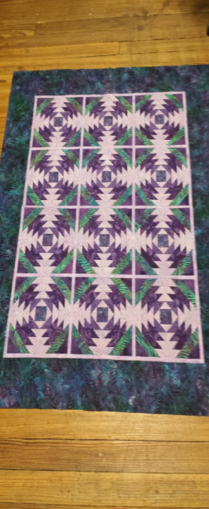Both Sessions will meet together for Embellishing and quilting on Tuesday 2:00pm -5:30pm in the Hudson Room.

Pineapple Fields designed by Tami Hemmer using the Creative Grid Ruler, adding sashing and putting pops of color in just the right “round” will get you a secondary design.
Choose Class II: Sunday from 9:00am-Noon OR Monday 2:00pm-5:30pm Both classes will meet on Thursday for finishing up Pineapple Fields.
Tami will be available during Open Sews in the evenings for questions and help in completing your Pineapple Fields Quilt.
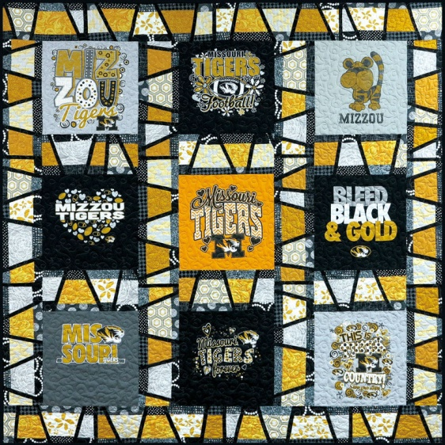“This T-Shirt Has Class” - Gather some of the T-Shirts you have been saving for that special T-Shirt Quilt and work with Wendy Rothermich to design your original, one of a kind T-Shirt Quilt. In this cruise special class, you will learn how to create stack and cut sashing.
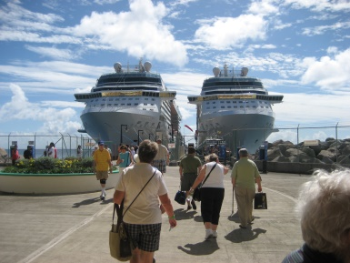Choose Class III on Sunday 9:00am-Noon OR Tuesday 2:00pm-5:30pm
Wendy will be available during open sew to offer help with your project.

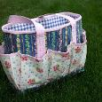“Project To Go Bag” Make this bag with Joyce, she has been on the search for the perfect bag to carry all the extra “gotta” haves for class and she finally found it thanks to Whistlepig Creek Productions and will be sharing it with you. This is the perfect bag for any Quilter to carry all the necessities to class, retreat or cruise. This tote has inside and outside expanding pockets and an optional drawstring closure.
Tote Bag measures 13"w x 10"h x 4-1/2"d and has lots of pockets.

Choose Class IV: Sunday 1:30pm-4:30pm OR Tuesday 2:00pm – 5:30-pm

“Lave Lamp” Beth Kurzava took the Lava Lamp template and created her modern version of the Lava Lamp Quilt. A simple process for an exqusit look.
Choose Class V Sunday 1:30pm -4:30pm OR Monday 2:00pm – 5:30pm
“Millie’s Mystery” Solve the quilt mystery with Millie – we can’t tell you cause it’s a mystery
Choose Class VI: Sunday 1:30pm – 5:30 pm OR Wednesday 2:00pm – 5:30pm

“Caribbian Stars Table Runner” A classic star with a twist makes up this fast and easy table runner using the Tucker Trimmer Ruler by Studio 180. Change the colors and create a special table for any of the holidays. Join Joyce a Studio 180 Certified Instructor to learn the in’s and out of the Tucker Trimmer Ruler.
Class VII is offered once on Wednesday 2:00pm – 5:30pm
“Star Table Topper” A table topper for a round or square table. Something simple and ellegant to make your table special. Joyce will lead you through this octigon table topper.
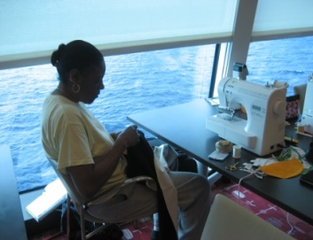Class VIII offered once on Thursday 9:00am-Noon
“Wrapping Rope” Gather with Beth to put new deminsion to a piece of rope. You will learn the technique while making a circle mat.
Class IX offered once on Thursday 9:00am-Noon

Choose Your Classes:
- Choose 3 to 4 Classes I – IX (1-9) at the time you desire at sea or in port.
- Choose as many of the evening projects you would like to make. These are projects where you can learn a new technique or make something very useful or wearable.
- Should you not want to invade your stash kits will be made availabe in consultation with the Instructor for an extra charge for Classes
- Projects will be availabe for you – all you need do is sign up to give us an idea of the number of kits we need to assemble.
- Supply lists will be provided for your selected classes upon payment of the $350 Quilt Cruise Fee.
- Sewing machines provided by Appletree Quilting Center will be by Bernina and Husquevarna Viking.

Hosts and Instructors for your cruise:
Toni Steere: with an in-depth understanding of all levels of the quilting industry, has been teaching quilting since 1988. Having taught dozens of energy-filled workshops nationwide for guilds, shops and the International Quilt Market, her projects can be found in catalogs and magazines.
She owned a quilt shop for 16 years, in 2007 co-founded Wing and a Prayer Design with her business partner, Jenny. Together they have designed countless patterns in addition to designing and curating several fabric collections for Timeless Treasures Fabrics, NY, NY
Outside of quilting, Toni enjoys her family, cooking, traveling and spending time at her lakeside cottage.
Toni joins Show Me Simply Quilt Cruise II where she will be teaching one of her original pattern designs Fringed in Fabulous. This quilt is a Fat Quarter friendly, quilt as you go 18" blocks embellished with decorative stitching while the raw edges create a fringed look.
Tami Hemmer: began her love of fabric in Jr High Home Ec classes. She enjoyed fabrics so much that while in high school she worked at a fabric store and took up garment sewing. About 20 years ago she pieced her first quilt and was hooked. Tami has made many kids quilts for children’s hospitals, and a variety of other quilts including paper piecing with Judy Neimeyer. Tami says: “ the more pieces to the quilt the happier I am.”
Beth Kurzava:
Wendy Rothermich:
Millie Kaiser:
Joyce Holley: percision machine piecing is Joyce’s passion. Joyce began teaching beginning quilters in the early 90’s and has developed the class called “In the Beginning”. Teaching and designing quilts has become her fulltime focus since retirieng as a United Methodist Pastor in 2015. To keep quilters growing and learning Joyce leads small group quilt trips to the Great Outdoor Quilt Show in Sister’s, Oregon and coordinates quilt cruises for groups who love the sea and quilting. In July of 2016 Joyce will become a Studion180 Certified Quilt Instructor.
Joyce will be teaching one of her designs “Star Chian table Runner” on this cruise.

